Test results for Lock material for unplanned issues — PC Barcode
Company A1 – Work Order W000167

1.PMC
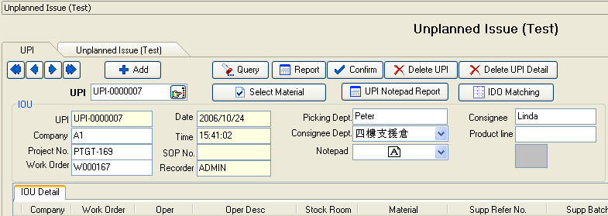

1>. New a UPI, input Company ,then input Project No. or WorkOrder ,select Consignee Dept , fill in other text if need,write down the Unplanned Issue Notepad in Notepad Memo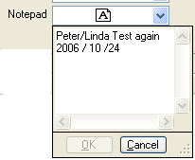;

2>.Click Select Material button .it will show the dialog to select ID(s):
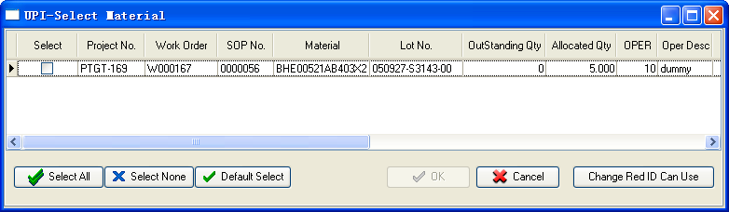

3>.select the ID(s) that you want ,then click OK button ;
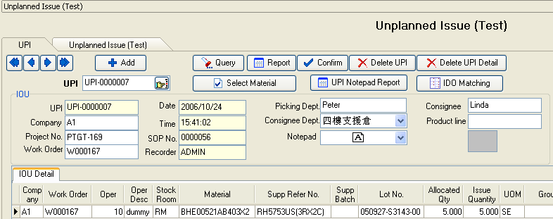

4>. Click Confirm button to Confirm ID(s) to Warehouse:
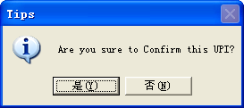
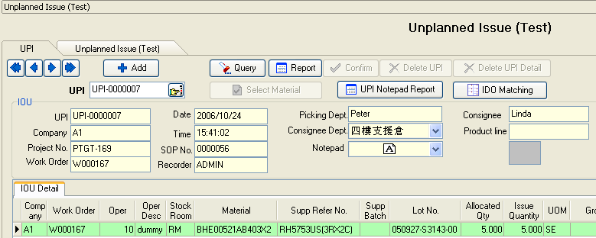

2.Warehouse

1>.Input UPI No. 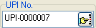 to get the record(s) which PMC Dept confirm to:
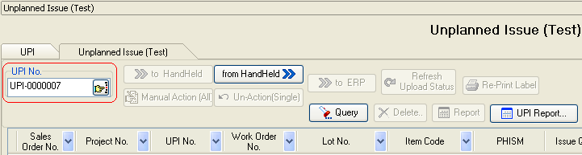
then press Enter;
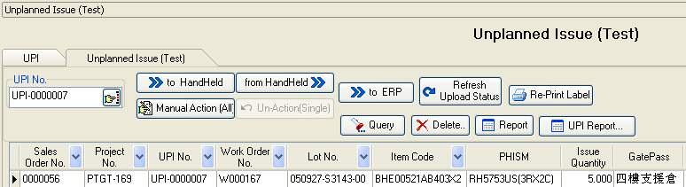
2>.Do transfer ID(s) to HandHeld and transfer from HandHeld ,it would have a Issue date:
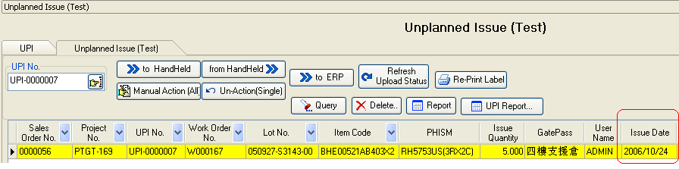
3>.Transfer data to AS400 ,please click :
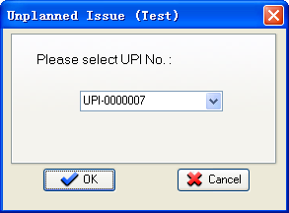
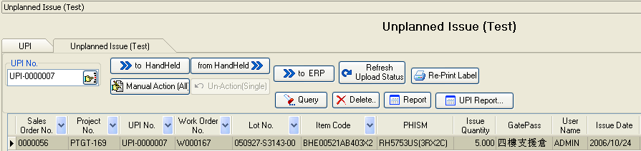

4>.in AS400 ‘42/PHGMENU’,upload APPI3U file to AS400:
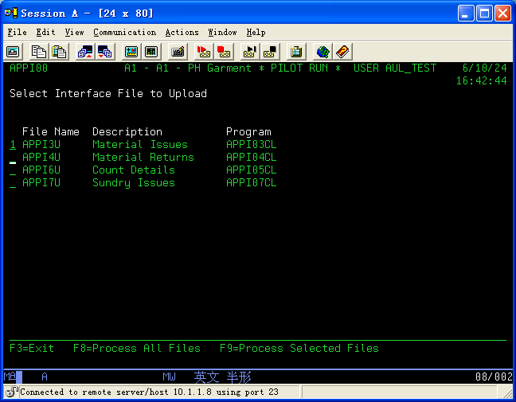

5>.click button  to check whether these ID(s) have Issued successful:
